Counting Squares
The motivation for this problem comes from the following puzzle
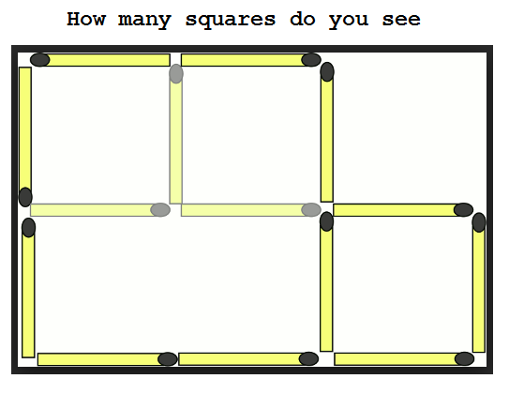

Consider the following 10 x 10 grid with 10 rows and 10 columns with 100 Lattice points. The following grid has 7 points labeled (letter A through G) and 2 edges. The seven points are located at the following points:
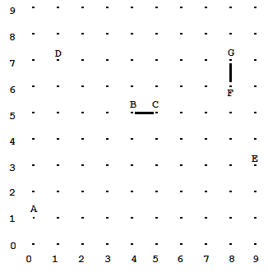
Note: the upper left corner is at point (9, 0),
the upper right corner is at point (9, 9),
the lower left corner is at point (0, 0),
and the lower right corner is at point (0, 9)

- is located above point (1, 0)
- is located above point (5, 4)
- is located above point (5, 5)
- is located above point (7, 1)
- is located above point (3, 9)
- is located below point (6, 8)
- is located above point (7, 8)

This problem is concerned with finding the number of squares formed by edges in a 10 x 10 grid. The size of a square is defined as the number of Edges that make up one side of the square. A quick reminder that a square has four equal straight sides and four right angles. Example shown at top contains 3 squares of size 1 and one square of size 2.
The 10 x 10 grid is repeated for your convience.

Two edges are shown in the grid: One edge connects points B and Point C and the second edge connects points F and G

Note: All Edges are length 1 and only connect points that are adjacent vertically or adjacent horizontally. No diagonal edges exist in this grid. In addition, Edges go both ways. That is, the edge that connects point B and C is exactly the same as the edge that connects point C and B.

This problem has two completed helper classes, the Point class and the Edge class. The Point class represents a Lattice point in the 10 x 10 grid with accessor methods getX() and getY() and a correctly implemented equals method. The Edge class represents an edge in the 10 x 10 grid with accessor methods getPointA() and getPointB() and a correctly implemented equals method.

In this problem you will complete three methods in the CountingSquares class. The CountingSquares class has an ArrayList<Edge> myEdges as an instance variable. The instance variable is initialized by the constructor. All problems assume a 10 x 10 grid and all Edges in myEdges are valid (0 <= getPointA() <= 9 and 0 <= getPointB() <= 9).

The first method to complete is: boolean hasSquare(Point lowLeftCorner, int length). hasSquare returns true if the grid contains the edges required to complete a square with size equal to length and the lower left corner of the square at Point lowLeftCorner .

The following code shows the results of the hasSquare method.
The following code | Returns
List<Edge> edgs1 = new ArrayList<Edge>();
edgs1.add( new Edge( new Point(1, 1), new Point(1, 2)));
edgs1.add( new Edge( new Point(1, 1), new Point(2, 1)));
edgs1.add( new Edge( new Point(1, 2), new Point(2, 2)));
CountingSquares cs = new CountingSquares(edgs1);
cs.hasSquare(new Point(1,1), 1);  // missing Edge connecting Point (2,1) & Point (2,2) | false
edgs1.add( new Edge( new Point(2, 1), new Point(2, 2)));
cs = new CountingSquares(edgs1);
cs.hasSquare(new Point(1,1), 1); | true

One more example on following page
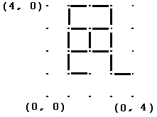
The code in the following tables shows the code to create the indicated Edges in a 10 x 10 grid.

The following code shows the results of the hasSquare method using the indicated 10 x 10 Grid.
The following code | Returns
List<Edge> edgs2 = new ArrayList<Edge>();
edgs2.add( new Edge( new Point(1, 1), new Point(1, 2)));
edgs2.add( new Edge( new Point(1, 3), new Point(1, 4)));
edgs2.add( new Edge( new Point(1, 1), new Point(2, 1)));
edgs2.add( new Edge( new Point(2, 1), new Point(2, 2)));
edgs2.add( new Edge( new Point(2, 1), new Point(3, 1)));
edgs2.add( new Edge( new Point(2, 2), new Point(2, 3)));
edgs2.add( new Edge( new Point(2, 2), new Point(3, 2)));
edgs2.add( new Edge( new Point(2, 3), new Point(3, 3)));
edgs2.add( new Edge( new Point(3, 1), new Point(3, 2)));
edgs2.add( new Edge( new Point(3, 3), new Point(3, 2)));
edgs2.add( new Edge( new Point(3, 1), new Point(4, 1)));
edgs2.add( new Edge( new Point(4, 2), new Point(4, 1)));
edgs2.add( new Edge( new Point(4, 3), new Point(4, 2)));
edgs2.add( new Edge( new Point(4, 3), new Point(3, 3)));
cs = new CountingSquares(edgs2);
cs.hasSquare(new Point(1, 1), 1); | false
cs.hasSquare(new Point(2, 1), 1); | true
cs.hasSquare(new Point(2, 2), 1); | true
cs.hasSquare(new Point(1, 1), 2); | false
cs.hasSquare(new Point(2, 1), 2); | true

Continue on for the second and third methods.
The second method to complete is: int getNumSquares(int length). getNumSquares returns the number of squares of size length in the 10 x 10 grid.
The following code shows the results of the getNumSquares method.
The following code | Returns
List<Edge> edgs3 = new ArrayList<Edge>();
edgs3.add( new Edge( new Point(1, 1), new Point(1, 2)));
edgs3.add( new Edge( new Point(1, 1), new Point(2, 1)));
edgs3.add( new Edge( new Point(1, 2), new Point(2, 2)));
edgs3.add( new Edge( new Point(2, 1), new Point(2, 2)));
cs = new CountingSquares(edgs3);
cs.getNumSquares(1); | 1
// adding more Edges to the Grid
edgs3.add( new Edge( new Point(2, 1), new Point(3, 1)));
edgs3.add( new Edge( new Point(2, 2), new Point(2, 3)));
edgs3.add( new Edge( new Point(4, 3), new Point(4, 2)));
edgs3.add( new Edge( new Point(3, 3), new Point(3, 2)));
edgs3.add( new Edge( new Point(2, 3), new Point(3, 3)));
edgs3.add( new Edge( new Point(3, 1), new Point(3, 2)));
edgs3.add( new Edge( new Point(4, 3), new Point(3, 3)));
edgs3.add( new Edge( new Point(4, 2), new Point(3, 2)));
edgs3.add( new Edge( new Point(2, 2), new Point(3, 2)));
cs = new CountingSquares(edgs3);
cs.getNumSquares(1); | 4

Continue on for the third method.
The third method to complete is: int getSizeOfLargestSquare(). getSizeOfLargestSquare returns the size of the largest square in the 10 x 10 grid.
The following code shows the results of the getNumSquares method.
The following code | Returns
List<Edge> edgs4 = new ArrayList<Edge>();
edgs4.add( new Edge( new Point(1, 1), new Point(1, 2)));
edgs4.add( new Edge( new Point(1, 1), new Point(2, 1)));
edgs4.add( new Edge( new Point(1, 2), new Point(2, 2)));
edgs4.add( new Edge( new Point(2, 1), new Point(2, 2)));
edgs4.add( new Edge( new Point(2, 1), new Point(3, 1)));
edgs4.add( new Edge( new Point(2, 2), new Point(2, 3)));
edgs4.add( new Edge( new Point(4, 3), new Point(4, 2)));
edgs4.add( new Edge( new Point(3, 3), new Point(3, 2)));
edgs4.add( new Edge( new Point(2, 3), new Point(3, 3)));
edgs4.add( new Edge( new Point(3, 1), new Point(3, 2)));
edgs4.add( new Edge( new Point(4, 3), new Point(3, 3)));
edgs4.add( new Edge( new Point(4, 2), new Point(3, 2)));
edgs4.add( new Edge( new Point(2, 2), new Point(3, 2)));
edgs4.add( new Edge( new Point(3, 1), new Point(4, 1)));
edgs4.add( new Edge( new Point(4, 1), new Point(4, 2)));
cs = new CountingSquares(edgs4);
cs.getSizeOfLargestSquare(); | 2

